Workshop - Current and potential rural tourism linked to agricultural and forestry activities
Case study
Rural tourism in the Transylvanian Highlands
The largest ecotourism destination in Romania
Objective of the workshop: Analyzing the profile of the rural, ethnocultural and ecological sustainable tourism demanders, as well as the different profiles that develop it in each project partner country.
The activity will share knowledge and experiences in each country of economic activities in the rural environment that are potentially linked to nature tourism:
- Presentation for each country of a compilation of the typology of agricultural, livestock and forestry activities, which currently carry out nature or rural tourism activities.
- Identification and presentation for each country of economic activities of potential interest for developing rural tourism activities.
- Present experiences of characterisation of the profile of nature tourists, at least one experience analyse the internal and external environment of tourism linked to agricultural, livestock and forestry activities, and to identify barriers to the development of economic activity.
- Identify the barriers to their development and the training needs that are potentially identified as necessary

How to arrive
The closest airport will be Sibiu Airport. The meeting point will be at Sibiu Airport at 15:00, on 16th of July. The ProPark team will arrive with the cars and bring you to the accommodation site, in Richiș village. If you arrive much earlier, you can have a walk in Sibiu city center and we can arrange a second meeting point there. If there are no good connections with Sibiu, you can also try Bucharest or Cluj Napoca airport. From these cities we will guide you how to reach Sibiu by train.
Accomodation
The accommodation will be at Casa Noah in Richis Village, each participant will have his own room with shared bathrooms. The hosts speak both English and German language as foreign languages. We will stay in 3 different houses inside the village, one next to each other:
Yellow House - https://www.flickr.com/photos/158640786@N06/albums/72157662446475787
Great House - https://www.flickr.com/photos/158640786@N06/albums/72157692809410245
Blue House - https://www.flickr.com/photos/158640786@N06/albums/72157665209967828
Additional information
- About the Transilvanian Ecotourism destination: https://en.colinele-transilvaniei.ro
- Local temperatures during summer time in Sibiu county will be during the day between 25-27 degrees Celsius, and between 15-17 degrees Celsius during the night
- For the field trips I reccomend you have confortable outdoor shoes and clothes, small backpacks, water bottles, rain coats, sun hats and sunscreen.

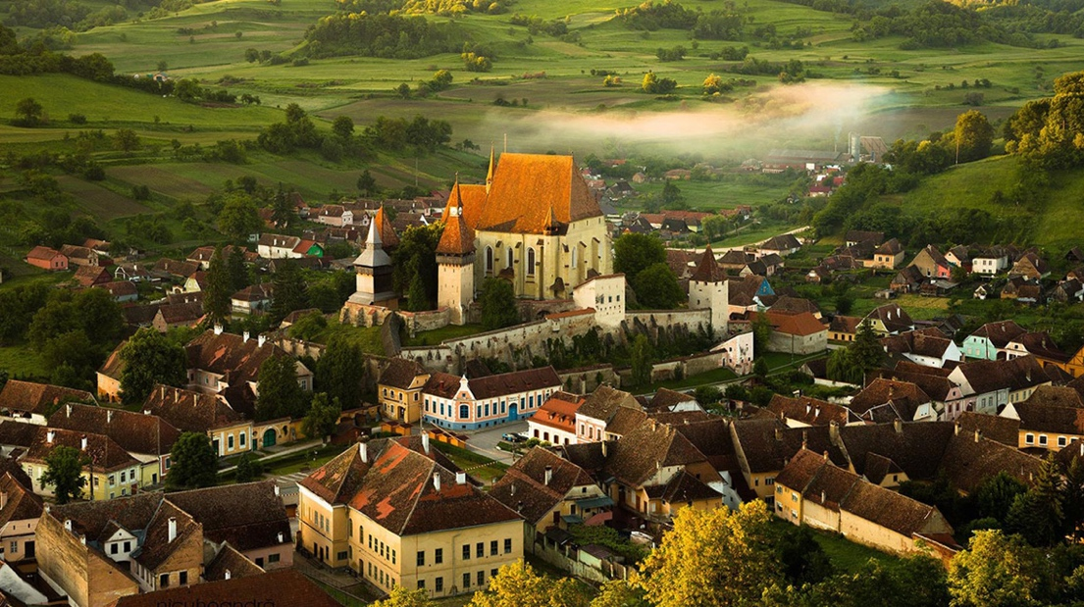
Draft Agenda
16-19 July 2023

Time schedule | Activity | Short description
16 July
15:00 | Sibiu Airport | Pick up the participants with ProPak cars. A pin location will be provided.
16:00 – 17:00 | Arriving in Richiș Village | Check in of the participants
17:00 – 19:00 | The story of Richiș Village | Worm welcome from the ProPark team and the host followed by a short-guided walk inside the village, understanding the history of the village, the local traditions, the local development and tourism infrastructure.
 | Wine samples in the village | Meeting locals and their local businesses
19:00 | Dinner | Diner at Casa Noah
17 July
8:30 – 9:30 | Breakfast | Casa Noah
9:30 – 12:00 | Group discussions | - Presentation of the Ecotourism destination Transilvanian Highlands and the vision of the ecotourism development in the rural areas in the southern Transylvania based on natural and cultural values.  - Discussions related to the profile of the rural, ethnocultural and ecological sustainable tourism demanders in ecotourism destination – Transilvanian Highlands
 |  | Each participants is asked to prepare and present a poster with the typology of agricultural, livestock and forestry activities, which currently carry out nature or rural tourism activities in their country.
12:00 – 13:00 | Biertan Fortified Church UNESCO Site | Explore through a guided tour the wonders and the stories behind the biggest fortyfied church in Transylvania. One of the unique attaractions of this destinations are these fortified churches that were once spread acorss 300 villages.
13:00 – 15:00 | Bio Mosna Farm (lunch included) | Discussions about Gastronomical Local Points and the development of a gastronomical infrastructure inside rural areas, connecting small local producers with tourists.  Lunch with local products from Bio Mosna farmland.
16:15 – 19:45 | Angofa Wildlife Center (dinner included) | The Angofa Wildlife Centre is the home base for biodiversity research, conservation, and wildlife tourism in Transylvania.  We will join an expert naturalist guide on a 1.5-hour walk through the lush forests and meadows of Angofa to learn to identify the unique birds, butterflies, and flowers of Transylvania.  We will learn how traditional farming practices protect wildlife and promote biodiversity surrounding transylvanian villages.  Return to the Angofa Wildlife Center for a fresh, three-course meal that highlights local agriculture and traditional Romanian dishes.  After our meal, join your naturalist guide for a discussion about the local wildlife, culture, and land management practices that protect Transylvania’s ecosystem.
20:00 – 22:00 | Sighisoara medieval city | Short walk inside the largest medieval fortress lived in Romania
23:00 | Return to Richis Village
18 July
8:30 – 9:30 | Breakfast | Casa Noah
9:30 – 11:30 | Group discussions (Lisov Museum coordinates the discussions) | - Present experiences of characterisation of the profile of nature tourists, at least one experience analyse the internal and external environment of tourism linked to agricultural, livestock and forestry activities, and to identify barriers to the development of economic activity.  - Identify the barriers to their development and the training needs that are potentially identified as necessary
12:00- 12:30 | Interetnic Museum of the Hartibaciu Valley, Altana | Visit a small rural museum that presents the past cultural life of the area.
13:00 – 14:30 | Hosman Village | Visit a local NGO Hosman Durabil that runs a wide range of local development activities in the rural area and followed by lunch at the Old Mill
14:30 – 17:00 | Hosman - Cornatel – Hosman | We will have a 8 km bicycle trolley experience on the former train traks that connected the villages, followed by a discussion on the reinterpretation of old infrastructure in order to develop opportunities in rural tourism.  https://sibiuagnitarailway.com/turism/
17:00 – 18:00 | Cornatel School Farm | Cornatel School Farm is an educational center in a rural area that functions as a school, teaching children about the farm animals and farm activities, and connecting the children with this environment
19:00-20:00 | Richis Village | Dinner at local families in Richis Village with final discussions
19 July – Departure of the participants
9:00 – 10:00 | Breakfast
10:00 - onwards | Departure to Sibiu Airport/Sibiu city center | The participants will be taken by cars to Sibiu city or Sibiu Airport in order to catch their flights back home.

Map of the Transylvanian Highlands ecotourism destination
